

Program Review Handbook

***August 2019***

Table of Contents

[1. Purpose of Program Review 3](#_Toc521571225)

[2. Overview: Programs and the Program Review Cycle 3](#_Toc521571226)

[3. ACCJC Standards and Program Review 4](#_Toc521571227)

[4. Preparing for Development of the Comprehensive Plan 4](#_Toc521571228)

[5. Writing and Submitting Program Plans and Results 6](#_Toc521571229)

[6. Assessment of Goals and Outcomes 8](#_Toc521571230)

[7. Reporting Progress and Assessment Results 9](#_Toc521571231)

[8. Timelines and Due Dates 10](#_Toc521571232)

[Appendix 11](#_Toc521571233)

[A. Sample Comprehensive Program Plans and Annual Updates 11](#_Toc521571234)

[B. Planning Resources and Links 13](#_Toc521571235)

[C. Screen-by-Screen Taskstream Instructions 15](#_Toc521571236)

[D. Program Groups and Annual Program Review Calendar 28](#_Toc521571237)

[E. Templates for Recording Planning Discussions 30](#_Toc521571238)

## 1. Purpose of Program Review

The fundamental purpose of Program Review is to support continuous improvement of programs and services based on the results of regular and systematic assessment. Program Review also supports the integration of planning, resource allocation, and institutional effectiveness. Engaging in thoughtful, regular cycles of planning, assessment, and analysis of results ensures the quality of City College programs and services and supports informed decision-making. Program Review enables reflection on the impact of instructional and student support activities on student learning, and contributes to attainment of the college’s mission, priorities, and strategic goals.

## 2. Overview: Programs and the Program Review Cycle

All areas of the college are expected to participate in Program Review, including both instructional and non-instructional Programs. In order to link Program Review with the allocation of resources, every area that has an assigned budget code will complete a Program Review. Instructional programs are organized around a curriculum that represents a coherent body of knowledge and skills that students develop in pursuit of a degree or certificate. Faculty actively engage in the definition of Student Learning Outcomes at the course and program levels, in alignment with Institutional Learning Outcomes. Non-instructional programs provide a variety of services to students and to other constituencies, such as college employees or the public. Non-instructional program areas are organized around key functions and reporting responsibilities. They may have Administrative Outcomes appropriate to unit functions and/or Student Learning Outcomes if there is a direct impact on student learning. Non-instructional program outcomes support Institutional Priorities, Strategic Goals, or Institutional Learning Outcomes as appropriate to their purpose and function.

Program Review has been an annual activity at City College for some time. ***Taskstream***, an online platform for recording assessment activities, is used to document Program Reviews as well as assessment of Student Learning Outcomes (SLOs) at the course level. In 2016–2017, MPAROC (the Master Planning, Assessment, and Resource Oversight Council) convened two work groups to examine options for instructional and non-instructional Program Review and recommend changes to the process that would: 1) streamline the number of separate entries required in Taskstream, and 2) focus Program Review on meaningful assessment of outcomes. The changes that were adopted include new templates in Taskstream that focus on documenting progress toward program goals; improved integration of resource requests; and a new three-year Program Review Cycle that lessens the intensity of the reporting requirements each year to support a greater emphasis on the use of results for improvement.

The three-year cycle begins with development of a Comprehensive Plan, followed by two years of annual updates. To make the transition from a one-year cycle to a three-year cycle, the following calendar has been approved:

|  |  |  |  |
| --- | --- | --- | --- |
| **YEAR** | **PROGRAM REVIEW EXPECTATIONS** | | |
| **2017–2018** | All programs develop a **C**omprehensive Plan using the new template | | |
| **2018–2019** | All programs complete an **A**nnual Update | | |
| **2019–2020** | The three-year cycle begins, with programs assigned to one of three groups: | | |
| Group I: Comprehensive | Group II: Annual | Group III: Annual |
| **2020–2021** | Group I: Annual | Group II: Comprehensive | Group III: Annual |
| **2021–2022** | Group I: Annual | Group II: Annual | Group III: Comprehensive |
| **2022–2023** | Group I: Comprehensive | Group II: Annual | Group III: Annual |
| **2023–2024** | Group I: Annual | Group II: Comprehensive | Group III: Annual |

A complete list of the programs expected to participate in Program Review, along with a detailed calendar by program, is presented in the Appendix and posted online at http://www.sdcity.edu/about/mission-priorities/program-review.aspx, along with a copy of this Handbook and other resources.

## 3. ACCJC Standards and Program Review

Effective and consistent Program Review processes are necessary to demonstrate that City College meets the expectations for institutional planning, assessment, and improvement processes set forth in the Accrediting Commission for Community and Junior Colleges (ACCJC) accreditation standards. Specific standards referring to program review include:

I.B.2: The institution defines and assesses student learning outcomes for all instructional programs and student and learning support services. (Eligibility Requirement 11)

I.B.4: The institution uses assessment data and organizes its institutional processes to support student learning and student achievement.

I.B.5: The institution assesses accomplishment of its mission through program review and evaluation of goals and objectives, student learning outcomes, and student achievement. Quantitative and qualitative data are disaggregated for analysis by program type and mode of delivery.

I.B.8: The institution broadly communicates the results of all of its assessment and evaluation activities so that the institution has a shared understanding of its strengths and weaknesses and sets appropriate priorities.

II.A.3: The institution identifies and regularly assesses learning outcomes for courses, programs, certificates and degrees using established institutional procedures. The institution has officially approved and current course outlines that include student learning outcomes. In every class section students receive a course syllabus that includes learning outcomes from the institution’s officially approved course outline.

II.A.11: The institution includes in all of its programs, student learning outcomes, appropriate to the program level, in communication competency, information competency, quantitative competency, analytic inquiry skills, ethical reasoning, the ability to engage diverse perspectives, and other program-specific learning outcomes.

## 4. Preparing for Development of the Comprehensive Plan

The Comprehensive Plan phase of the Program Review process calls for thoughtful engagement and dialogue about your program’s purpose and impact. These discussions should allow all faculty and staff in the program to contribute. The table below includes suggested topics of discussion and some guiding questions that can help to identify information to include in your Comprehensive Plan.

|  |  |
| --- | --- |
| TOPIC | GUIDING QUESTIONS FOR DISCUSSION |
| **Results of Outcomes Assessments** | * What are the results of our assessments of outcomes[[1]](#footnote-2)? * What is working well? * What needs improvement? * What factors are contributing to our success or impeding our progress on our outcomes? * Do our outcomes need updating? |
| **Equity** | * Do the enrollment demographics of our program participants reflect the college as a whole? * How do we use disaggregated data in examining outcomes? * How have we considered disproportionately impacted groups in our outcomes assessment? In our design and delivery of instruction or services? * Do our assessment results show evidence of equity in outcomes attainment? * What outreach efforts are we engaging in, and do we have evidence these are effective? |
| **Student Success and Achievement** | * What do you observe in the data on success and achievement measures[[2]](#footnote-3)? * Do any groups seem to be performing higher or lower than expected? What might be the reasons? * How have success and achievement changed over time? How does this reflect the evolution of your program? |
| **Partnerships** | * What partnerships has your program established within and outside the college? * How do these partnerships contribute to accomplishment of your program’s goals? * Are there new partnerships that would be beneficial to establish? |
| **Innovation** | * What changes or innovations have you introduced, and what do you understand about their impact? * Have innovations been implemented consistently by different people or across different parts of your program? * What changes or innovations might address areas where your program would like to improve? |
| **Governance** | * What level of participation and representation does your program have in college governance groups? * How do you receive and share information about college governance processes and decisions? * Are you satisfied with the input you have in planning and decision-making? Are there areas you would like to improve? |
| **Curriculum** | * What new courses, certificates, or degrees have been added? * Are there new courses, certificates, or degrees planned? * Have changes been made to prerequisites? * Have courses or programs been archived or discontinued? * Have you considered or implemented learning communities, Open Educational Resources, or other alternative approaches to learning? |

|  |  |
| --- | --- |
| **Scheduling and Modes of Delivery** | * Has the program reviewed schedule changes (course additions and cancellations) to incorporate into future schedule planning? * Is there a two-year plan for course offerings? * Does the schedule support student progression through your program in the time expected to complete? * Are online or hybrid courses offered? Are there differences observed in student enrollments or performance? |

Other resources that should be considered in thinking about how your program’s Comprehensive Plan aligns with the college as a whole:

City Institutional Priorities and Strategic Goals

Institutional Priorities[[3]](#footnote-4):

* Student Success
* Innovative Approaches
* Equity, Inclusiveness, and Diversity
* Collaborative and Outreach Ventures
* Environmental Stewardship
* Institutional Accountability
* Strategic Planning

Strategic Goals 2017–2020[[4]](#footnote-5):

* Fiscal Stability and Sustainable Funding
* Strategic Enrollment Management
* Communication and Collaboration
* Community Connections
* Equity, Inclusion, and Learning Support

## 5. Writing and Submitting Program Plans and Results

City College uses Taskstream, an online software service, to record and report the Program Review process, including plans and results. If you need a Taskstream login, please contact the Administrative Technician in Institutional Effectiveness, Kathleen Custodio, at [kcustodio@sdccd.edu](mailto:kcustodio@sdccd.edu).

In an effort to help faculty and staff construct a comprehensive program plan for both instructional and non-instructional programs in the college, two fictitious examples have been created for demonstration and are included in the Appendix. Please refer to these examples when reading the instructions. These examples are just that and should not be taken as the only way to construct a comprehensive program plan.

Comprehensive program plans should be constructed following extensive documented dialogue with all the stakeholders. The accrediting commission will be looking for evidence of dialogue on campus. Please use the template provided for recording a summary of your program dialogue; other systems for meeting notes are fine as long as substantially the same information is addressed. Screenshots from Taskstream are included to assist with navigation.

The Program Purpose/Mission statement

The purpose/mission statement of your program should fit within the college’s overall mission. A mission statement should state why the program exists, what it does, and what it intends on achieving. See examples provided for an instructional and non-instructional program.

Program outcomes

All instructional programs have outcomes that have been documented in the college catalog. These outcomes need to be listed in the program comprehensive plan. If an instructional program decides to alter the outcomes listed in the catalog, the program needs to follow processes the college has in place for making changes to the catalog. Until the desired changes have been made and published in the catalog, program outcomes listed in the comprehensive plan must match the current catalog and should also be posted on the program’s page on sdcity.edu, the college website. .

Non-instructional programs do not have outcomes listed in the catalog but must list the current administrative or student learning outcomes for the program in the comprehensive plan. These outcomes should be constructed following an extensive and documented dialogue with all stakeholders.

Assessment of Program Outcomes is recorded each year in Taskstream using a specific form that can be opened from the left-hand menu. This form is available on the same schedule as the Comprehensive Plan. Screenshots and directions are available within Taskstream and are included in the Appendix. Program Outcomes represent the mission or purpose of your program and broadly state what your program or service will accomplish. Program Outcomes are assessed as part of the Program Review cycle alongside the development of a Comprehensive Plan. For outcomes that you select for assessment in this Program Review cycle, you will need to define one or more measures. For each measure, the following information is requested:

* Measure Title: Brief name for the measure
* Measure Type/Method: A drop-down menu that allows you to select options for direct or indirect assessments
* Description of the method of evaluation or assignment selected to measure this outcome
* Criteria for success: What result or threshold would indicate the outcome has been attained?
* Action Plan and Confirm Completion: What are you doing about the results you have observed relative to your Program Outcome(s)? If you are proposing a specific action, this section should be updated when it is completed.

Comprehensive Plan: Goals for Improvement

In addition to supporting ongoing attainment of your program outcomes, you may also have a vision for the future. This vision can guide the program by focusing your attention on where the program wants to be, the achievements, and the goals that will be accomplished in three years. The vision for the program should be created with input from as many stakeholders as possible. In the Comprehensive Plan, this vision is stated as a goal to be achieved during the next three years. Stakeholders should discuss all the goals for the program they may be interested in. However it is recommended that the goals be rank ordered and the program pick no more than three goals per comprehensive program plan. As the numbers of goals increase so will the workload. Therefore it is imperative that the discussion to choose the goal(s) and strategies for achieving the goal be discussed ahead of time. Again documentation of these discussions is imperative for accreditation purposes. In order to address accreditation standards, programs need to make sure that goals support the attainment of Program Outcomes, but these can be more focused actions. Please see fictitious examples of the instructional and non-instructional programs below.

Strategies for Accomplishing Program Goals

For each goal, stakeholders also need to discuss the desired outcome(s) for and the strategy(ies) that will be used to accomplish each goal. A strategy is simply the action(s) that will be taken to accomplish the goal. Please see examples. Strategies can be anything from a professional development activity to collecting data using focus groups, to acquisition of a new piece of equipment. The strategy has to move the program towards accomplishing the goals.

## 6. Assessment of Goals and Outcomes

Each strategy needs to include types of assessment that will be used to measure the movement of the program towards accomplishing the goals. In other words, stakeholders need to know and discuss ahead of time how they will measure their progress. This requires strategies for which meaningful quantitative or qualitative data can be collected. See examples.

Properties of good assessment:

Valid—reflects the goal or learning outcome being assessed

Reliable—the reproducibility of results over time; measure of consistency

Actionable—results point reviewers toward challenges that can be approached

Efficient ---cost-effective in time and money

Engaging--students can demonstrate the extent of their learning

Interesting---encourages stakeholders to care about results so they are willing to act

Triangulation—multiple lines of evidence to help point to the same conclusion

Assessment techniques, methods, and strategies should align with the outcome being measured and the types of data available. A brief overview is provided here; for more in-depth discussion of options, contact the SLO Liaison for your program or the City College Research Office, [cityresearch@sdccd.edu](mailto:cityresearch@sdccd.edu).

Assessment Techniques

**Direct** – These assessment methods require students to directly demonstrate their learned knowledge, skills, abilities, attitudes or behavior. For example:

1. Locally developed tests and quizzes
2. Portfolios or Capstone Projects
3. Explicit self-reflective writing or journaling on what has been learned
4. Pre/post assessment of learning

**Indirect** – These assessment methods either ask students to reflect on their learning rather than demonstrate it, or imply learning through indirect measures. For example:

1. Perception/Attitudinal Surveys
2. Focus group studies
3. Success, retention and persistence rates
4. Number of students who complete an Education Plan

*Assessment Methods*

**Quantitative**: Data that are collected as numerical counts or statistical values. These data are used to express quantities and are often used to categorize, compare or generalize. These data are used to capture rates, or trends.

**Qualitative**: Data that are collected as descriptive information such as narratives or verbatim responses from open-ended questions on surveys or interviews. These data require a content analysis in order to understand underlying themes. Qualitative approaches are often used to capture a wide array of feedback or to evaluate depth of understanding.

Assessment Strategies

**Formative**: An assessment strategy used to assess ongoing progress or learning for the purpose of providing corrective feedback. Formative assessment helps to establish or define a foundation for next steps in the learning process or improvements to an administrative process.

**Summative**: An assessment strategy used to evaluate completed activities or learning and to determine proficiency. Summative assessment informs decisions regarding readiness for the next step or learning experience.

Planning for Improvement

Assessment results should inform decisions about instruction or services that lead to improvement when outcomes are assessed in the next cycle. “Closing the loop” is critical for meaningful assessment and effective Program Review. Assessment results may show evidence that the intended result was attained, which could lead to planning for expanding scope or capacity. At times, assessment results may indicate that the program or service did not have the intended effect; planning might focus on whether the assessment techniques, methods, and strategies are appropriate, or making adjustments to implementation that can be assessed going forward. The guiding questions in Section 4 above are useful in evaluating results and planning for improvement.

Resource Requests

Requests for resources in support of program goals will now be submitted in Taskstream along with Program Review documents. These include:

* Position requests for full-time Faculty. Forms will be available in Taskstream and will be completed and uploaded each year that a contract position is being requested. These requests will continue to go through the Faculty Hiring Prioritization process involving the Chairs and School Deans with new scoring criteria that are included with the form.
* Position requests for full-time Classified positions. These requests will be reviewed and prioritized as outlined in the position request form.
* Budget requests for general funds. These forms will be distributed by the Vice President of Administrative Services to budget managers and will be completed and uploaded to Taskstream as an attachment to the Program Review submission each year. These requests will be considered through the Resource Allocation Committee (RAC) process.
* Technology requests: Blank forms are available in Taskstream. This process is currently under revision.

## 7. Reporting Progress and Assessment Results

Following the creation of a Comprehensive Plan, the next phase of the cycle is to provide a progress update on results, accomplishments, and adjustments. Program Outcomes are reported on each year in the ***Program Outcomes Assessment*** tab in the left-hand menu. You will see the outcome defined previously as well as how the outcome will be measured and the criteria for success established. Results can be updated in the “Findings” section and any follow-up can be documented in the “Action Plan” section. If the assessment will be ongoing, or if you will make adjustments, or if the evaluation is completed, that can be noted here. Any supporting documentation can be uploaded as an attachment in this section.

For each Comprehensive Goal you defined in your Comprehensive Plan, there is space in the template to report progress. Use the ***Comprehensive Goal #1*** (or #2 or #3) tab in the left-hand menu to access the template. Check out the form and scroll down to the “Annual Update 2019-2020” section. Here you have space to report results in the “Program Review (Findings)” box and describe what you will do in response to what you’ve learned in the “Program Plan (Action)” box.

The final section addresses resource requests. As in the original Comprehensive Plan, you will describe the resources needed to support attainment of program outcomes and/or improvement goals, provide a rationale for each type of resource request, and click the “Save and Return” button. Complete the appropriate attachments and add them under the ***Budget Requests*** or ***Hiring Requests*** tab(s).

See the calendar in Part D of the Appendix to learn which phase of the cycle your program will complete in a given year.

## 8. Timelines and Due Dates

Program Review submittals should be completed in Taskstream by November 1 of each year. To engage in participatory planning and have tasks completed by this due date, the following timeline is recommended:

|  |  |
| --- | --- |
| **MONTH** | **TASKS** |
| **August** | * Clarify responsibilities for documenting dialogue within programs and entering information into Taskstream. * Develop agendas for program/unit discussions in September and October. |
| **September** | * Review current Program Outcomes, ISLO mapping, and and available data. * Use the Guiding Questions from the Program Review Handbook and document dialogue using the meeting template. |
| **October** | * Identify actions for improvement to be taken in the coming year and any associated resource requests. * Document dialogue using the meeting template. |
| **NOVEMBER 1** | * Complete required entries in Taskstream and upload completed resource request forms. |

All programs completed a Comprehensive Plan in fall 2017, followed by a Progress Update in fall 2018. Refer to the Appendix for a detailed map of the Program Review Cycle for 2018–2019 and beyond, as from this point forward there will be a staggered cycle with about one-third of City College programs developing a Comprehensive Plan each year.

# Appendix

## A. Sample Comprehensive Program Plans and Annual Updates

Instructional Program

**2017-2020 Comprehensive Program Plan**

**Program Name:** Muggle Studies

**Contact Person:** Professor Snape, program lead, [snape@hsw.edu](mailto:snape@hsw.edu), or X1234

**Program Mission:** To provide wizards with a strong background in critical analysis, structure of language, linguistics, scientific and literary background for a more complete understanding of muggles and muggle culture.

**Current Program Student Learning Outcomes:** Upon completion of the Muggle Studies Program students will be able to:

1. Demonstrate Muggle cultural fluency and awareness.
2. Critically analyze the study of Muggle behavior as it relates to the development of wizarding policy and procedures in essays, written assignments, and papers.
3. Identify and describe main concepts in Muggle studies including political structure of Muggle

society, Muggle history.

*NOTE: Program student learning outcomes listed here have to match the program outcomes published in the catalog. Programs wishing to change their outcomes need to do so in Curricunet and have them appear in the catalog before they can be used here for assessment.*

Outcome 1: Demonstrate Muggle cultural fluency and awareness

|  |  |
| --- | --- |
| Measure: Describe the method of evaluation or assignment that you have chosen to measure this OUTCOME. | Program faculty will review student papers and presentations from MUGG 220 and 230 using a rubric to assess understanding of aspects of Muggle culture |
| Criteria for Success: What is the measure goal? | 85% of students will demonstrate fluency on all elements |
| Findings: Describe the results based on the current assessment plan? | Assessment of spring 2018 student work found that 28/32 students (87.5%) demonstrated fluency on all elements |
| Action Plan and Confirm Completion: What action is being taken to improve the program? Was it completed? | This approach to assessment will be continued until completion of the full Program Review cycle. At that time the rubric will be reviewed for any needed updates. Assessment results will be used along with student interviews to update the program website and brochure. |

**Program Goals for Improvement:**

Muggle Studies Goal 1: The Muggle Studies Program will increase success and retention rate of students in the program by three percentage points a year for three years.

Goal #1 Strategies:

Strategy 1.1–Success and retention in Muggle Studies will be increased by providing appropriate professional development needed to improve instruction.

Strategy 1.2–Success and retention in MUGG 101 will be increased by employing SI tutoring in all sections of MUGG 101.

Goal #1 Explanation: We have observed that the drop/non-complete rate in MUGG 101 has increased slightly over the past three years. This course is a prerequisite for all other courses in the program. We want to ensure that all students have the support needed to be successful and that course design is optimally supporting learning.

Goal #1 Measures: 1.1 – retention in successive terms; degree completion. 1.2 – course success rates for MUGG 101

Resources: Professional development for program faculty—workshop guest speaker $500; additional SI tutors— $2,000

Resource Rationale: An on-campus workshop with an invited guest speaker on classroom engagement strategies would be more cost-effective than sending individuals to off-campus training. Other departments could participate depending on available space. Data from Institutional Research shows that Supplemental Instruction tutoring is an effective strategy for students from disproportionately impacted groups.

|  |  |
| --- | --- |
| Program Review (Findings): The effectiveness of the professional development activities was measured using faculty and student surveys and success and retention data from Muggle Studies courses. Success and retention will also be measured before and after SI tutoring is introduced.  Faculty evaluation of the professional development activities was positive, with all 12 participants reporting that they learned new approaches they will use in their teaching this year. Short in-class surveys of students indicated they responded positively to the use of inclusive engagement strategies. Monitoring of course success rates is in progress. | Program Plan (Action): Follow-up surveys of faculty and students will be conducted to assess whether the use of interactive strategies is sustained. Discussion and exchange of ideas will be added to department meeting agendas. Strategies will be shared during the Block Party. Annual data updates from the Research Office will be used to monitor course success rates. |

Non-Instructional Program

**2017–2020 Comprehensive Program Plan**

**Program Name:** Owl Postal Service

**Contact Person:** Owl handler, [ohand@hsw.edu](mailto:ohand@hsw.edu), or X5678

**Program Mission:** Transport and deliver mail into and out of Hogwarts School of Wizarding and Witchcraft.

**Current Program Administrative Outcomes**: The Owl Postal Service Program has the following Administrative Outcomes.

1. Letters sent by staff and students will be delivered accurately and on time.
2. Owl Postal Service operations will respond to periods of high demand by increasing service capacity.

Outcome 2: Owl Postal Service operations will respond to periods of high demand by increasing service capacity.

|  |  |
| --- | --- |
| Measure: Describe the method of evaluation or assignment that you have chosen to measure this OUTCOME. | Services provided during extended hours will be tracked to document levels of use. Staff and students will also be asked for feedback on how well the services meet their needs. |
| Criteria for Success: What is the measure goal? | At least 90% of students and their families will report that they are satisfied or highly satisfied with owl post services at the end of the term. |
| Findings: Describe the results based on the current assessment plan. | In the first six months of increased services, an average of 35 additional items per week were sent or received. Service was provided to an average of 12 students per week. A feedback survey will be sent to all users at the end of the term. |
| Action Plan and Confirm Completion: What action is being taken to improve the program? Was it completed? | The Owl Postal Service will place notices in the Daily Prophet and include a flyer with the instruction packets for first year students to ensure parents and families are aware of the service and evening hours for assistance. |

**Program Goals for Improvement:**

Owl Postal Service Goal 1: The Owl Postal Service will improve Program Administrative Outcome 2 by ensuring adequate service to evening students.

Goal #1 Strategies:

Strategy 1.1: The Owl Postal Service will add evening hours two days per week by procuring extra owls.

Strategy 1.2: Marketing efforts will be expanded to ensure that students and families are aware of the service.

Goal #1 Explanation: While most Hogwarts School business is accomplished during the day, students are more likely to want to send or receive mail in the evening. To ensure adequate service levels, staffing will be offered two nights per week and additional owls will be provided.

Goal #1 Measures: Services provided (number of users, letters sent/received); student and parent feedback surveys

Resources: 10 additional school owls (estimated cost 15 Galleons); four hours of part-time office assistant per week (estimated cost 200 Galleons); advertising in Daily Prophet (10 Galleons)

Resource Rationale: New and/or Muggle-born students may need personal assistance to use owl post. Owls sent on daytime deliveries may not return in the same day, so additional capacity is needed.

|  |  |
| --- | --- |
| Program Review (Findings): In the first six months, an average of 35 items/week were sent or received in the evening. Staff provided assistance to an average of 12 students per week. Feedback surveys are planned for the end of the fall term. | Program Plan (Action): Continue expanded service through the year and complete assessment process to evaluate whether expansion should be made permanent. |

## B. Planning Resources and Links

City College Mission, Values, and Institutional Priorities:

<http://www.sdcity.edu/about/mission-priorities/index.aspx>

City College 2017–2020 Strategic Plan

<http://www.sdcity.edu/about/mission-priorities/docs/city_2017_strategic_plan.pdf>

City College 2016–2025 Educational Master Plan

<https://www.sdcity.edu/about/mission-priorities/docs/2016-2025-ed-master-plan.pdf>

City College Research Reports

<http://www.sdcity.edu/about/institutional-effectiveness/research/reports-resources.aspx>

San Diego Community College District Research Reports

<http://research.sdccd.edu/>

Goal Setting Worksheet (flowchart from the University of Texas – resource for goal discussions)

<http://deanofstudents.utexas.edu/leadership/downloads/GoalSettingWrkshtFall2012.pdf>

Program Review Data Packets including data on student characteristics, success outcomes, and productivity are distributed to department Chairs via School Deans each fall.

For assistance with research requests or data interpretation, contact the City College Research Office at [cityresearch@sdccd.edu](mailto:cityresearch@sdccd.edu).

Each semester, the Assessment Coordinator hosts a series of open labs for assistance working in Taskstream or other questions related to outcomes assessment. Please check your email or the Flex calendar for the most up-to-date schedule.

## C. Screen-by-Screen Taskstream Instructions

**Signing In to Taskstream**

1. To log in to Taskstream, go to www.taskstream.com

2. Click on the Sign Up/Login link located upper right.

\*If you do not have an account please contact the campus Assessment Coordinator. Contact information can be located at [http://www.sdcity.edu/faculty-staff/outcomes/index.aspx.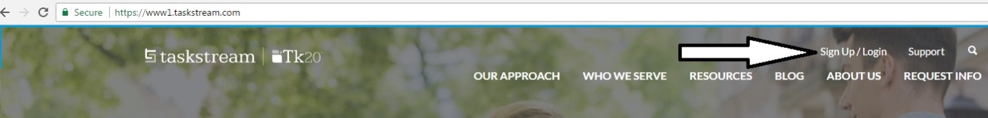](http://www.sdcity.edu/faculty-staff/outcomes/index.aspx.)

3. Log In with your designated screen name and self-selected password.

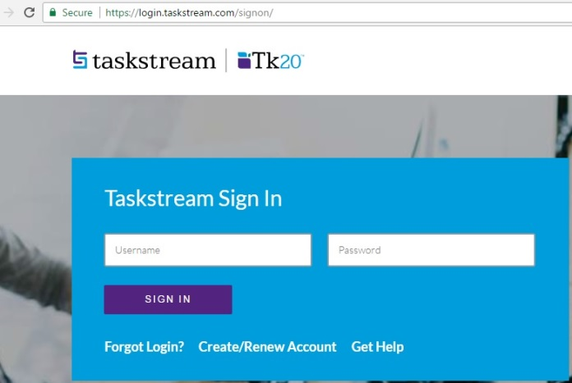

**COMPREHENSIVE PROGRAM PLAN SECTION**

\*Annual Plan Update Instructions listed below.

**Accessing and Editing Your Affiliations for Comprehensive Program Plan and Updates**

1. Once signed in, you can locate your program in the provided list.

\*If you need access to additional areas of Taskstream please contact the on campus Assessment Coordinator.

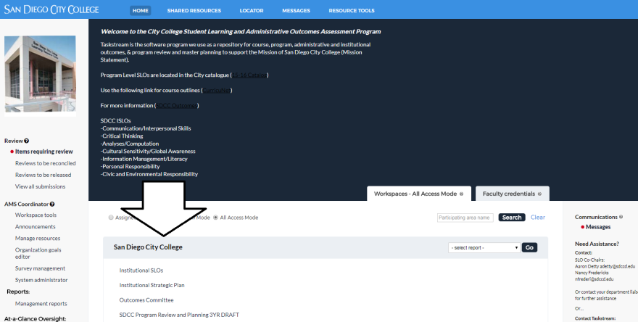

2. Click the link “Comprehensive Program Plan and Annual Updates” under your program.

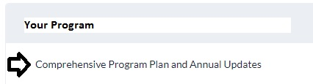

3. Once you enter your “Comprehensive Program Plan and Annual Updates” page, the links and additional information will be located in the left column.

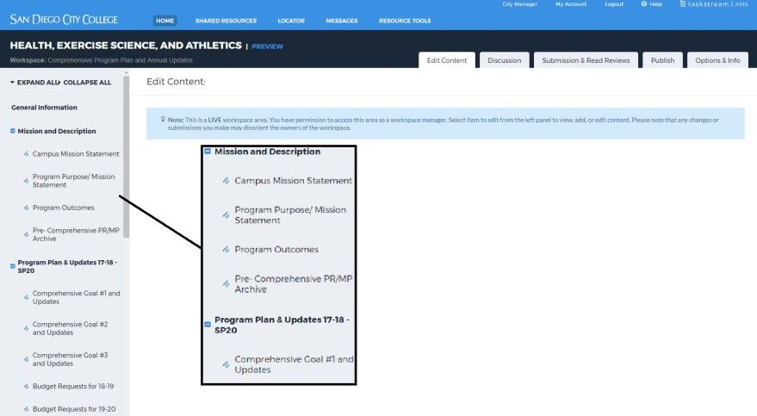

4. To edit an area, click the title link and click “Check Out” on the upper right corner of page.

**

**Completing your Program Outcomes Assessment**

*This will include a measure, criteria for success, findings (data), and an action plan for program improvement*

1. Click on “Program Outcomes Assessment” and “Check Out.”

*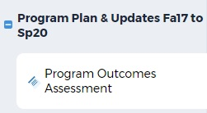*

1. If you are starting a new Assessment click “Create New Assessment Plan” and if you are continuing an Assessment click “Copy Existing Plan as Starting Point.” Please note all work starting in the new Plan (fall 2017) will not have existing plans.



1. If new, click select existing set and then add your Outcomes by clicking the check mark and click continue.
2. Now select the Outcome by checking the box and click “Accept and Return to Plan.”
3. 
4. To input your assessment click “Add Measure.”



1. Complete the form and click “Apply Changes.”



**Editing Comprehensive Plan Goals 1-3**

1. Click on the “Comprehensive Goal #1 (or 2-3) and Updates” link and click “Check Out.”

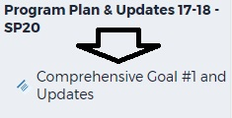

2. Click on “complete this form.”

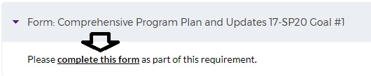

3. Enter your data and narrative, then click “Save and Return” (Located at top and bottom right of the form).

**

**Uploading Files to the “Budget Request” Link**

1. Click the “Budget Requests” Link and “Check Out.”



2. Click the attachment link at the bottom of the page.



3. Click the link “Upload from Computer.”

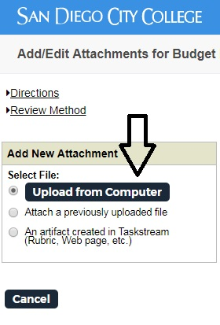

4. Click on link, lower left, “+Add Files.”

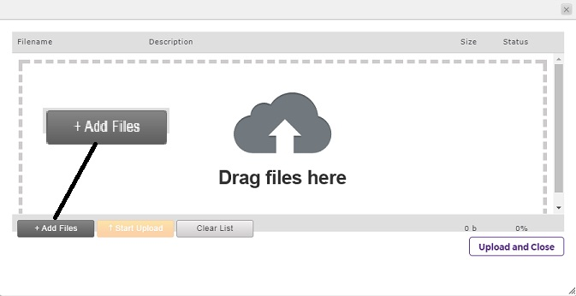

5. Select your files and click “Open.”

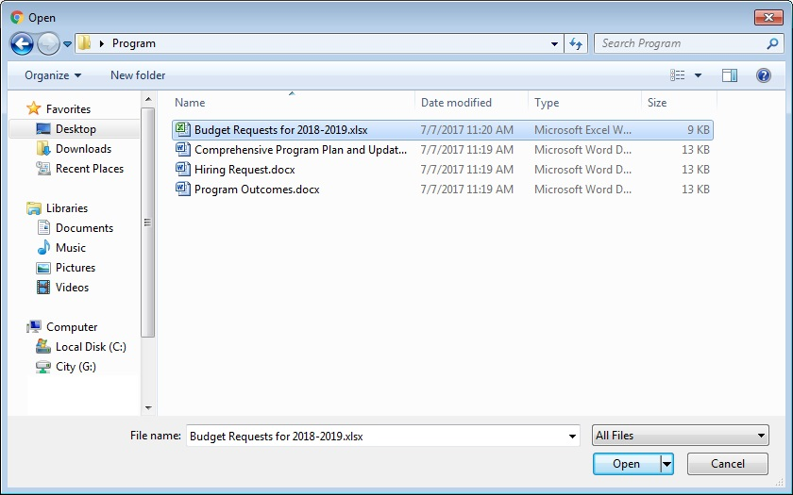

6. Click “Upload and Close.”

*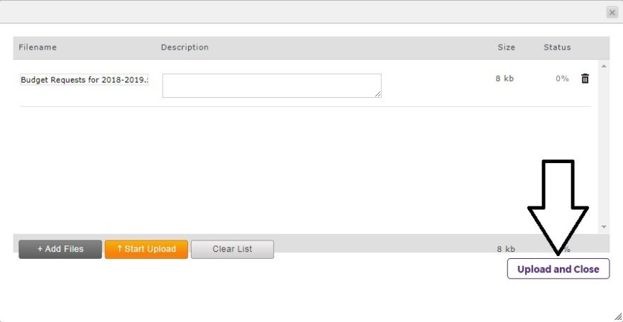*

**Uploading Files to “Hiring Requests” Link**

1. Click the “Hiring Requests” Link and “Check Out.”



2. Download the appropriate hiring request form and complete the form.

3. Once the form is ready to be uploaded, click the “Attachments” link at the bottom of the page.



4. Click the link titled “Upload from Computer.”



5. Click on the link, lower left, “+Add Files.”



6. Select your files and click “Open.”

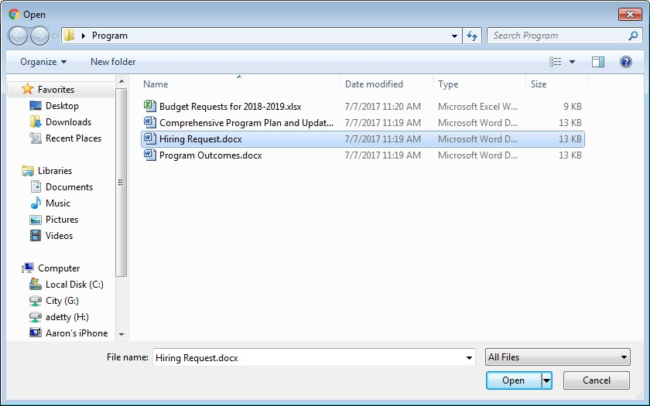

7. Click “Upload and Close.”

**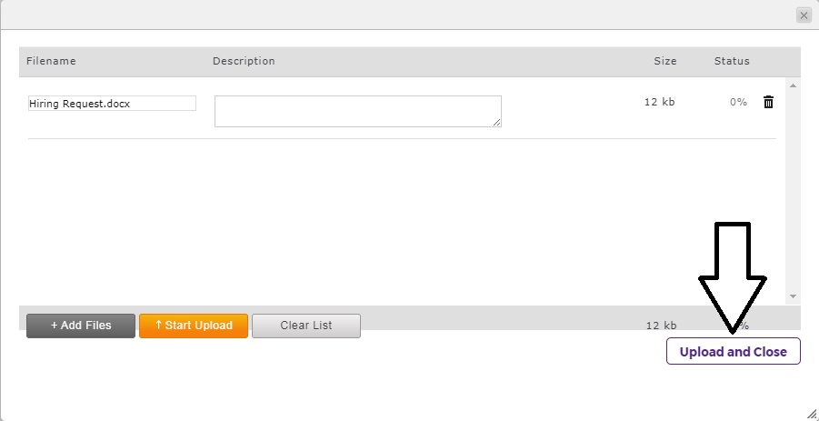**

**Submitting Your Completed Work**

1. Once you have completed your work, click on C:\Program Files (x86)\Microsoft Office\MEDIA\OFFICE14\Bullets\BD21301_.gifSubmission & Read Reviews. The link is located in the horizontal tabs near the top in grey.

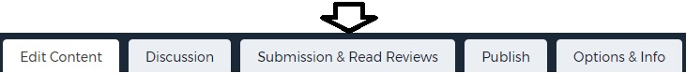

2. Locate the area you intend to submit and click the blue button titled, “Submit Work.”



3. The work is then forwarded to the supervisor of your program.

4. If an area needs to be unlocked, please contact your supervisor or the assessment coordinator.

**ANNUAL PLAN UPDATE YEAR SECTION**

*Please refer to your calendar to identify an update year.*

**

*Update Checklist*

1. Update Program Outcome Assessment Data
   1. Plan next steps- Review Measure
   2. Input Findings (Results)
   3. Input Action Plan
   4. Identify responsible individuals for Action Plan
   5. Attach documents directly related to the Assessment. This can include linkage of program or course outcomes to ISLOs.
   6. During the cycle each Program Outcome should be measured. Instructions to add a measure is listed after the Assessment Update instructions.
2. Update Progress in Goal Form
   1. Plan next steps- Review Goals
   2. Input Program Review (Findings)
   3. Input Program Plan (Action)
   4. Input Resources
   5. Input Resource Rationale
   6. Indicate Requested Areas
   7. Attach documentation of meetings and any other documents related to the program
3. Attach Budget Request Form
4. Attach Hiring Requests

**Updating Program Outcome Assessment Data**

1. Click on “Program Outcomes Assessment” and “Check Out.”

**

1. Locate the Measure that is in progress and click “Edit.”



1. Input your Findings, Action Plan, and Responsible Personnel. (If the measure is ongoing, provide an update of status)

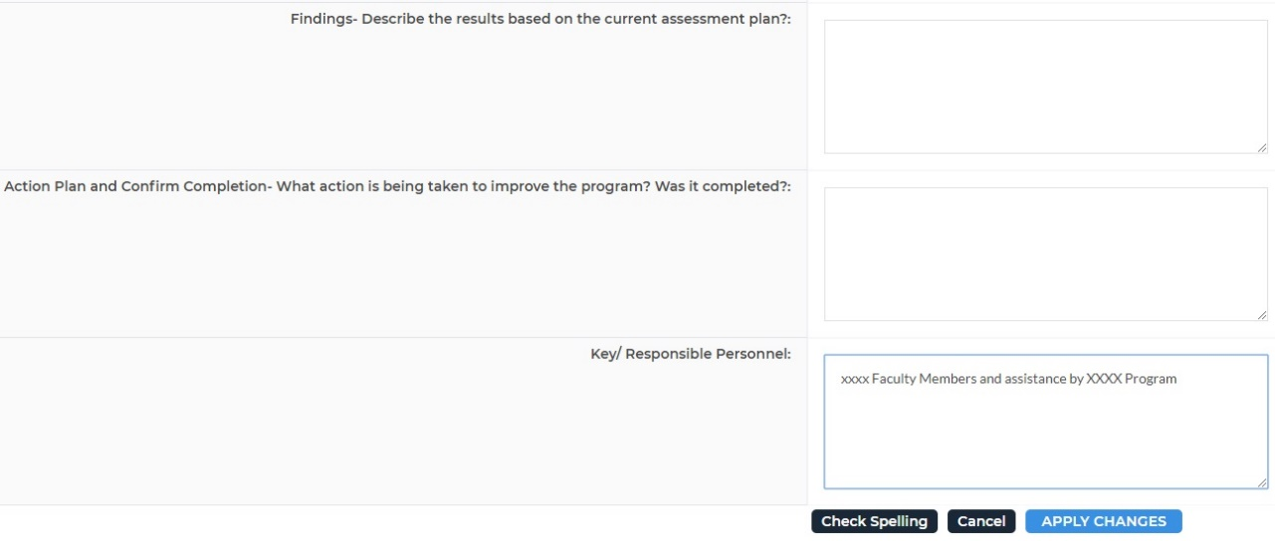

1. Complete the form and click “Apply Changes.” 
2. Attach supporting documents directly related to the Assessment Plan.



1. Click Check In 

**Adding a NEW Assessment during an Update Year**

1. If you are adding/starting a new Assessment click “Create New Assessment Plan” and if you are continuing an Assessment click “Copy Existing Plan as Starting Point.” Please note all work starting in the new Plan (fall 2017) will not have existing plans.



1. If new, click select existing set and then add your Outcomes by clicking the check mark and click continue.
2. Now select the Outcome by checking the box and click “Accept and Return to Plan.”
3. 
4. To input your assessment click “Add Measure.”



1. Complete the form and click “Apply Changes.”



1. Click “Check In.” 

**Update Progress in Goal Form**

1. Click on the “Comprehensive Goal #1 (or 2-3) and Updates” link and click “Check Out.”

**

2. Click on “Edit” or “View/ Edit Your Responses.” 

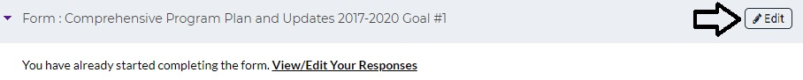

1. Enter your data and narrative for the Annual Update section including Program Review (Findings), Program Plan (Action), Resources, Resource Rationale, and Indicate Requested Areas.

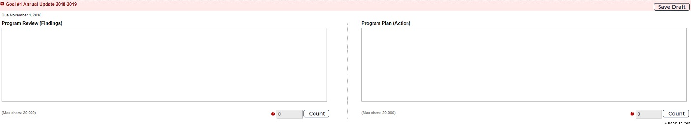

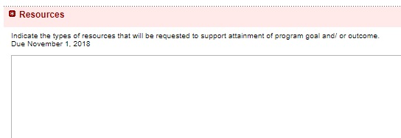

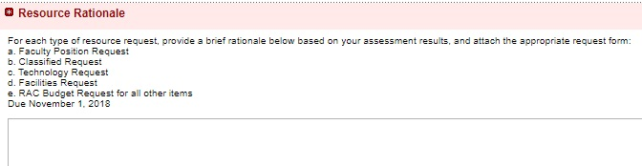

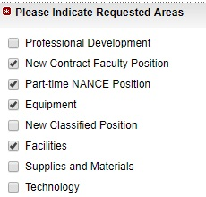

1. Click “Save and Return” (Located at top and bottom right of the form).

**

1. Attach supporting documents.
2. Click the attachment link at the bottom of the page.



1. Click the link “Upload from Computer.”



1. Click on link, lower left, “+Add Files.”



1. Select your files and click “Open.”

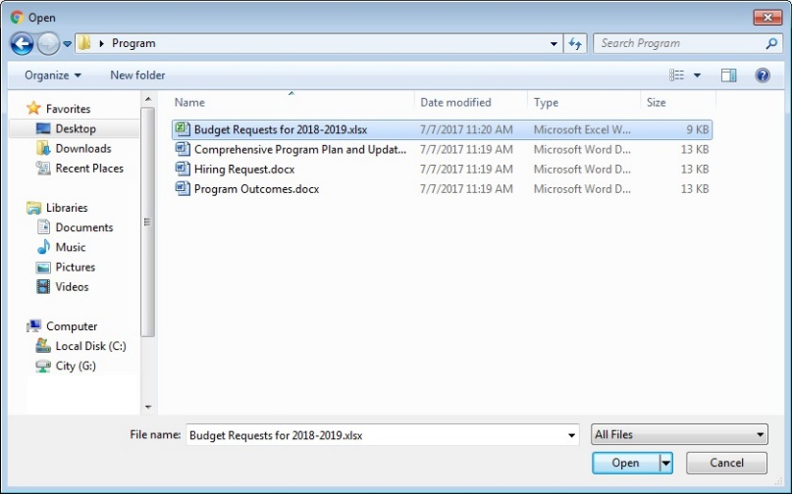

1. Click “Upload and Close.”



1. Click “Check In.”

**Attach Budget Request Form**

**Uploading Files to the “Budget Request” Link**

1. Click the “Budget Requests” Link and “Check Out.” Select the preceding Academic Year.

\*If it is Fall 2018, select AY 19-20.



2. Click the attachment link at the bottom of the page.



3. Click the link “Upload from Computer.”



4. Click on link, lower left, “+Add Files.”



5. Select your files and click “Open.”



6. Click “Upload and Close.”

**

1. Click Check In

**Attach Hiring Requests**

1. Click the “Hiring Requests” Link and “Check Out.” Select the preceding Academic Year.

\*If it is Fall 2018, select AY 19-20.



1. Download the appropriate hiring request form and complete the form.
2. Once the form is ready to be uploaded, click the “Attachments” link at the bottom of the page.



1. Click the link titled “Upload from Computer”.



1. Click on the link, lower left, “+Add Files.”



1. Select your files and click “Open.”



1. Click “Upload and Close.”

****

1. Click “Check In.” 

## D. Program Groups and Annual Program Review Calendar

**COMPREHENSIVE PLAN/ANNUAL UPDATE CYCLE**

|  |  |  |  |  |  |  |  |  |  |  |  |
| --- | --- | --- | --- | --- | --- | --- | --- | --- | --- | --- | --- |
|  | 2019–2020 | 2020–2021 | 2021–2022 | 2022–2023 | 2023–2024 | 2024–2025 | 2025–2026 | 2026–2027 | 2027–2028 | 2028-2029 | 2029-2030 |
| **Group I** | **Compre-hensive** | Annual Update | Annual Update | **Compre-hensive** | Annual Update | Annual Update | **Compre-hensive** | Annual Update | Annual Update | **Compre-hensive** | Annual Update |
| **Group II** | Annual Update | **Compre-hensive** | Annual Update | Annual Update | **Compre-hensive** | Annual Update | Annual Update | **Compre-hensive** | Annual Update | Annual Update | **Compre-hensive** |
| **Group III** | Annual Update | Annual Update | **Compre-hensive** | Annual Update | Annual Update | **Compre-hensive** | Annual Update | Annual Update | **Compre-hensive** | Annual Update | Annual Update |

|  |  |  |  |  |  |  |  |  |
| --- | --- | --- | --- | --- | --- | --- | --- | --- |
| PROGRAM REVIEW ROTATION | |  | | |  |  | |  |
| **GROUP I** | | **GROUP II** | | **GROUP III** | | | | |
| **Program Name** | **School/Unit** | **Program Name** | **School/Unit** | **Program Name** | | | **School/Unit** | |
| Air Conditioning, Refrigeration and Env. Control Technology | ETMS | School of BSS | BSS | School of AHC | | | AHC | |
| Electricity | ETMS | Anthropology | BSS | English | | | AHC | |
| Electronic Systems | ETMS | Conflict Resolution and Mediation | BSS | English Center | | | AHC | |
| Engineering | ETMS | Future Studies | BSS | English for Speakers of Other languages | | | AHC | |
| Engineering Technology | ETMS | Psychology | BSS | Humanities | | | AHC | |
| Machine Technology | ETMS | Social Work | BSS | Labor Studies | | | AHC | |
| Manufacturing Engineering Technology | ETMS | Sociology | BSS | Philosophy | | | AHC | |
| Dance | AHC | Black Studies | BSS | Mathematics | | | ETMS | |
| Dramatic Arts/Theatre | AHC | Chicano/a Studies | BSS | Math Center | | | ETMS | |
| Fine Art | AHC | History & Political Science | BSS | MESA | | | ETMS | |
| Graphic Design | AHC | School of ETMS | ETMS | Life Sciences | | | ETMS | |
| Music | AHC | Nursing Education | ETMS | School of ILT | | | ILT | |
| Photography | AHC | Astronomy | ETMS | Library (Faculty) | | | ILT | |
| School of BITC | BITC | Chemistry | ETMS | Learning Resource Center | | | ILT | |
| Business Studies | BITC | Geography, Geology, GIS | ETMS | Tutoring | | | Instruction | |
| Business and Computer Systems | BITC | Physical Science | ETMS | CalWorks\CARE | | | Student Svcs | |
| Cosmetology | BITC | Physics | ETMS | Counseling Department | | | Student Svcs | |
| Information Technology | BITC | Digital Journalism | AHC | DSPS | | | Student Svcs | |
| Career Education | BITC | Radio, Television and Film | AHC | EOPS | | | Student Svcs | |
| Alcohol and Other Drug Studies | BSS | Communications | AHC | Price Scholars | | | Student Svcs | |
| Child Development | BSS | Languages Department | AHC | Puente | | | Student Svcs | |
| Human Svcs | BSS | School of HESA | HESA | Umoja | | | Student Svcs | |
| President's Office | President | Health, Exercise Science, & Athletics | HESA | Personal Growth | | | Student Svcs | |
| Institutional Effectiveness | President | Athletics | HESA | VP of Administrative Svcs | | | Admin Svcs | |
| Marketing and Public Information | President | Fitness Specialist | HESA | Business Svcs | | | Admin Svcs | |
| Student Equity | Student Svcs | Health & Exercise Science | HESA | Digital Print Room & Mail Room | | | Admin Svcs | |
| Admissions / Records | Student Svcs | VP of Instruction | Instruction | Stockroom & Receiving | | | Admin Svcs | |
| Assessment Testing | Student Svcs | Off-Campus Programs | Instruction | Student Accounting | | | Admin Svcs | |
| Financial Aid | Student Svcs | World Cultures | Instruction |  | | |  | |
| First Year Svcs | Student Svcs | Academic Senate | Instruction |  | | |  | |
| Mental Health Counseling Center | Student Svcs | Articulation | Instruction |  | | |  | |
| Outreach | Student Svcs | Honors | Instruction |  | | |  | |
| Student Affairs/Associated Student Government | Student Svcs |  |  |  | | |  | |
| Student Development/ Matriculation | Student Svcs |  |  |  | | |  | |
| Student Health Clinic | Student Svcs |  |  |  | | |  | |
| Student Transition Svcs | Student Svcs |  |  |  | | |  | |
| Veterans Affairs | Student Svcs |  |  |  | | |  | |
| VP of Student Svcs | Student Svcs |  |  |  | | |  | |

## E. Templates for Recording Planning Discussions

The templates below are provided to document the planning conversations and dialogue around outcomes and goal development that occur within each program. This documentation is important in demonstrating that planning is a meaningful and participatory process engaged in across the college. Capturing your discussion and uploading this information to your Program Review site in Taskstream makes it available for future reference. You may also use your existing format for minutes or notes.

Screenshots are provided here as an illustration. Fillable PDF versions are available at

<http://www.sdcity.edu/about/mission-priorities/program-review.aspx>.



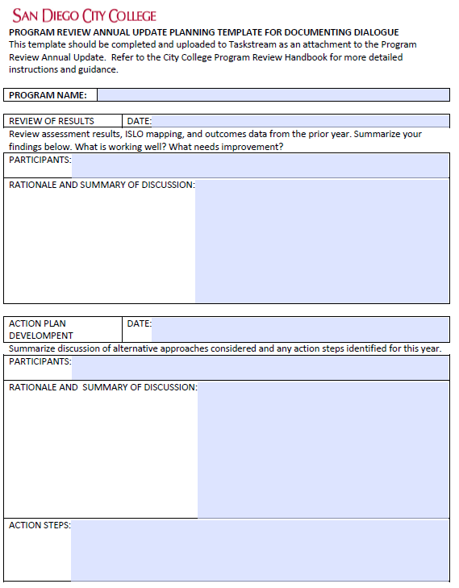

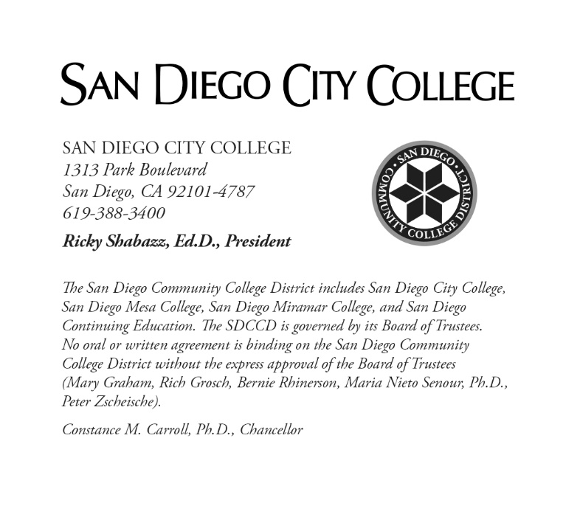

1. For Instructional programs, this discussion should encompass Course and Program SLOs. Student Services programs and Administrative areas should consider their program/service Administrative Outcomes and any Student Learning Outcomes defined for the program. [↑](#footnote-ref-2)
2. These include student retention, success, completion, GPA, transfer, employment, licensure pass rates, etc. [↑](#footnote-ref-3)
3. <http://www.sdcity.edu/about/mission-priorities/index.aspx> [↑](#footnote-ref-4)
4. <http://www.sdcity.edu/about/institutional-effectiveness/planning.aspx> [↑](#footnote-ref-5)