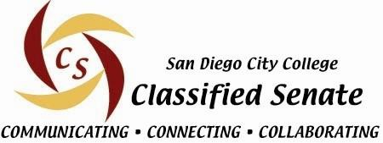
SDCC Classified Senate Exec Meeting Thursday, September 23, 2021
2:00pm to 3:00pm

Meeting Notes
- Budget
  - Regular updates
    - Cal Coast Acct: Saving $604.37 and Checking $2054.84
    - Block Grant $8167.00
    - Campus SC Account $10,486.00 (increase of $1786.00 on 2103 object code)

- DGC / College Council / President’s Meeting
  - AFT site meeting, concern about reporting process after COVID reported
  - Safety concerns, empty campus
  - Students concerned about communications regarding COVID, including multiple conflicting email/instruction information
    - Sean mentioned leveraging our digital signage boards
    - Direct students with questions to Welcome Tents
(right now it’s at Admissions, sometimes at AH/BT quads)
  - Funding is opening up for student housing
    - State Grant opening for MSI (Minority Serving Institution).
    - Student Services developing a plan
  - Susan Murray is hosting events/activities to help in accreditation preparation. Her style of zoom meetings seems to work well, very interactive with Admin. Board, etc.
    - Regarding accreditation, how are people chosen for appointments and self-studies? (Sean will ask Susan)

- Professional Development

  - PDAC/CSPD
    - Sean is working with the new coordinators
    - A needs survey is going on
  - Upcoming activities
    - Itza Vilaboy will meet with PDAC-1st meeting ????
    - New Hire Institute starting again, meeting Oct. 4th.
  - Classified Appreciation Day (Oct. 21) – replacing the 28th date
    - 2:00 pm – 4:00 pm
    - Halloween costume challenge
    - Fall wallpaper – zoom background
    - Halloween wallpaper – zoom background
    - We can independently search for virtual fall activities

- Adopt-A-Family –
Oct. 11 – Announcement
Nov. 26 – Applications due
Nov. 29 - Dec. 3 – screen and tally applicants
Dec. 4 – Senate Picks
- Notify students Dec. 6 (gift cards sent virtually)
- Last days of classes Dec. 17

- Senate Office
  - Sean plans to be there at least by-weekly
  - Feel free to go and organize/straighten up
  - Possibility of storing seldom used supplies in ILC storage unit
    - Sean will share video/pix of the space and more info

- Roundtable
  - CFT Conference – contact Tina Fletcher at AFT
    - Who from City is going?
    - Connect with attendees – see if they will share at an open meeting and find a date for them to share
    - See if anyone wants to meet up there
    - May we forward their invitation?
    - When is the cutoff date?
    - How many spots are still available?

(in attendance: Ryan, Temmy, Joan)

